import java.sql.*;

public class Testing1 {

public static void main(String[] args) {

try{
Class.forName("com.mysql.cj.jdbc.Driver"); //Register

Connection con=DriverManager.getConnection(
"jdbc:mysql://localhost:3306/test","root","root");

Statement stmt=con.createStatement();

ResultSet rs=stmt.executeQuery("select * from student");
// -----------up to this line it contain's one table struc output
while(rs.next()){
System.out.println(rs.getInt(1)+" "+
rs.getString(2)+" "+rs.getInt(3));
}
con.close();
}
catch(Exception e){
System.out.println("Sorry for the inconvinence happened..! "
+ "Check the inputs properly one more time");
}
}

}

show databases;

create database test;
use test;
create table student(sid int unique not null, sname varchar(30) not null,smarks int not null);

desc student;
insert into student values(105,'Arthi',92);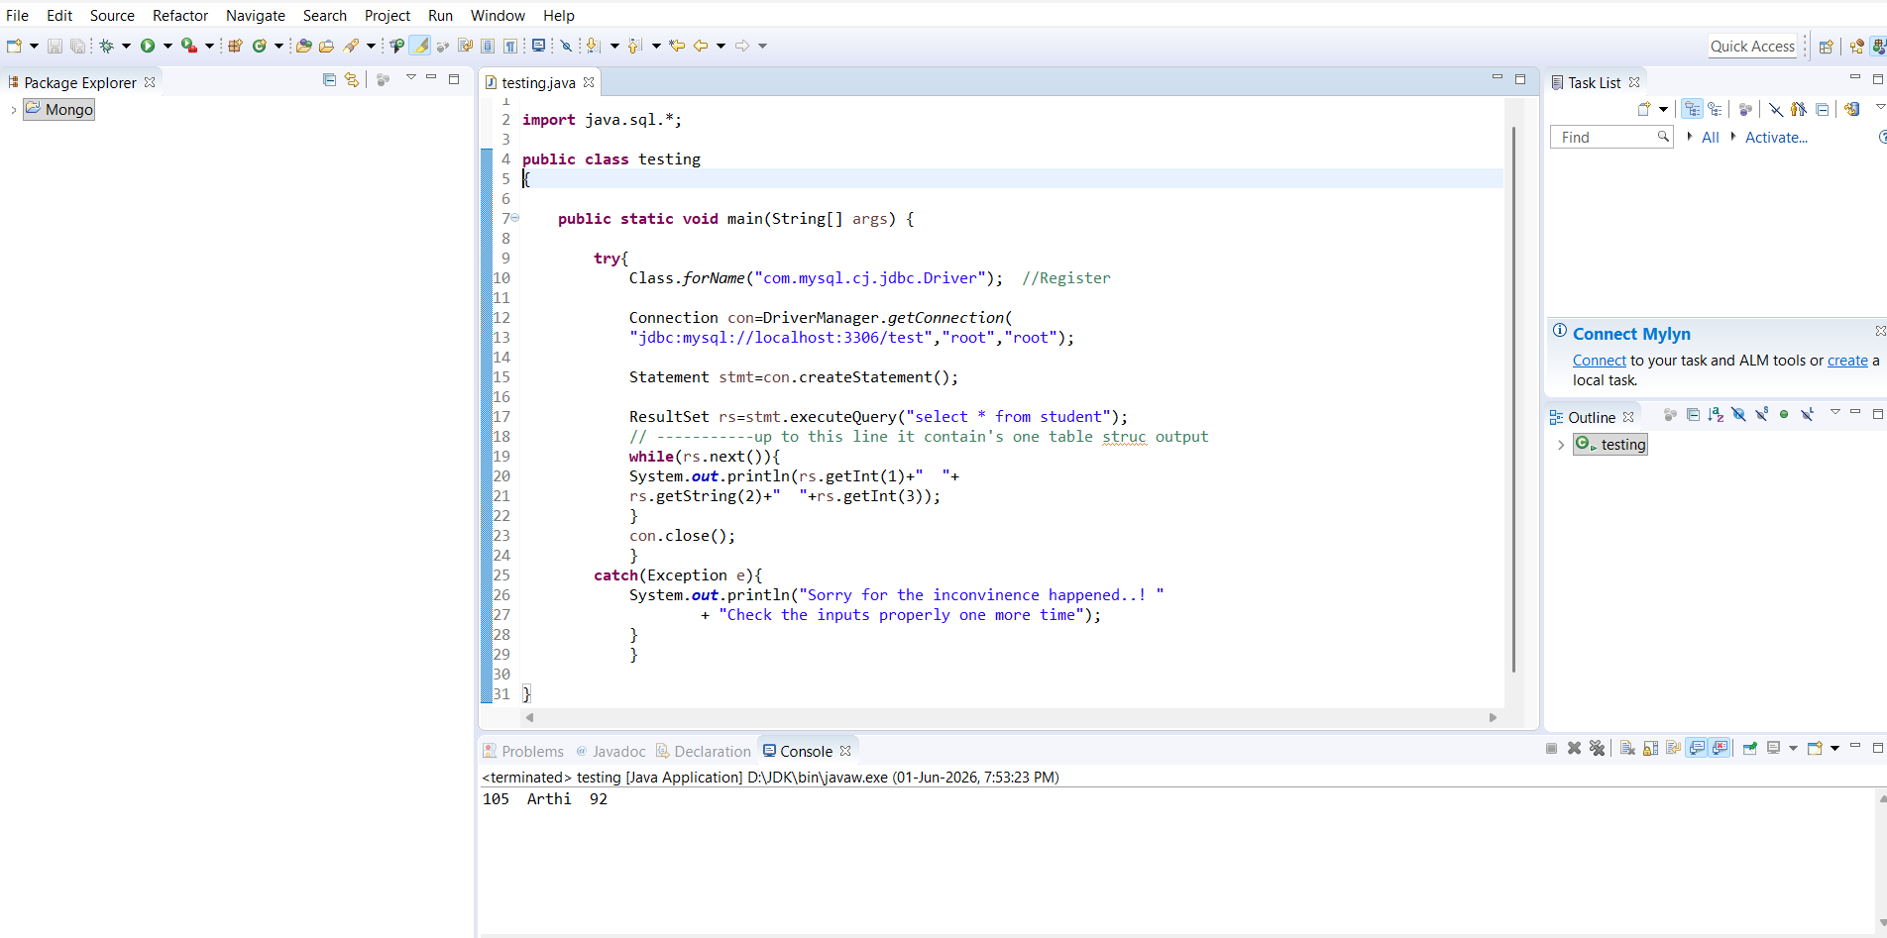
package CRUD;

import java.sql.Connection;
import java.sql.PreparedStatement;
import java.sql.ResultSet;

public class CRUD_Test {

public static void main(String[] args) {

CRUD_Test objTest = new CRUD_Test();

// INSERT DATA (Sakshi)
objTest.create_data("2", "sakshi singh", "sakshi@gmail.com");

// READ DATA
objTest.read_data("2");

// UPDATE DATA
objTest.update_data("2", "22", "jawad2", "jawad2@gmail.com");

// DELETE DATA
objTest.delete_data("1");
}

// CREATE
public void create_data(String sl_no, String name, String email){

Connection connection = DB_Connection.get_connection();
PreparedStatement ps = null;

try {
String query = "insert into user(sl_no,name,email) values (?,?,?)";
ps = connection.prepareStatement(query);

ps.setString(1, sl_no);
ps.setString(2, name);
ps.setString(3, email);

ps.executeUpdate();

} catch (Exception e) {
System.out.println(e);
}
}

// READ
public void read_data(String sl_no){

Connection connection = DB_Connection.get_connection();
PreparedStatement ps = null;
ResultSet rs = null;

try {
String query = "select * from user where sl_no=?";
ps = connection.prepareStatement(query);

ps.setString(1, sl_no);

rs = ps.executeQuery();

while(rs.next()){
System.out.println("Sl no -" + rs.getString("sl_no"));
System.out.println("name -" + rs.getString("name"));
System.out.println("email -" + rs.getString("email"));
System.out.println("---------------");
}

} catch (Exception e) {
System.out.println(e);
}
}

// UPDATE
public void update_data(String sl_no, String new_sl_no, String name, String email){

Connection connection = DB_Connection.get_connection();
PreparedStatement ps = null;

try {
String query = "update user set sl_no=?,name=?,email=? where sl_no=?";
ps = connection.prepareStatement(query);

ps.setString(1, new_sl_no);
ps.setString(2, name);
ps.setString(3, email);
ps.setString(4, sl_no);

System.out.println(ps);
ps.executeUpdate();

} catch (Exception e) {
System.out.println(e);
}
}

// DELETE
public void delete_data(String sl_no){

Connection connection = DB_Connection.get_connection();
PreparedStatement ps = null;

try {
String query = "delete from user where sl_no=?";
ps = connection.prepareStatement(query);

ps.setString(1, sl_no);

System.out.println(ps);
ps.executeUpdate();

} catch (Exception e) {
System.out.println(e);
}
}
}
